DBMS ASSIGNMENT – 4

AGGREGATE FUNCTIONS

***Roll Number: U19CS012***

***Name: BHAGYA VINOD RANA***

**Q1)** Create a table **Employee** with fields

EmpID Number (6) Primary key

Name Character (25)

Department Character (30)

Manager ID Number (6)

JoiningDate Date

Salary Number (8)

Insert 15 Rows in the above created table.

**SQL-Code [**SQLite 3.29.0**]:**

BEGIN TRANSACTION;

CREATE TABLE EMPLOYEE(

    emp_id integer PRIMARY KEY,

    emp_name text,

    department text,

    manager_id integer,

*-- YEAR MONTH DAY [Important Mistake!]*

    joining_date DATE,

    salary integer

);

*-- Insert 10 Rows in the above created table.*

INSERT INTO EMPLOYEE VALUES(

    4123,

    'Ninja_Hatori',

    'Production',

    1002,

    '2020-04-01',

    65000

);

INSERT INTO EMPLOYEE VALUES(

    4129,

    'Ajay',

    'Research',

    1027,

    '2018-04-02',

    45000

);

INSERT INTO EMPLOYEE VALUES(

    4230,

    'Mickey',

    'Marketing',

    1022,

    '2016-04-03',

    35000

);

INSERT INTO EMPLOYEE VALUES(

    4428,

    'Kiteretsu',

    'Accounting',

    1012,

    '2019-04-04',

    75000

);

INSERT INTO EMPLOYEE VALUES(

    4073,

    'Shizuka',

    'HR',

    1035,

    '2020-04-05',

    60000

);

INSERT INTO EMPLOYEE VALUES(

    4983,

    'Aditya',

    'HR',

    1035,

    '2017-04-06',

    100000

);

INSERT INTO EMPLOYEE VALUES(

    4009,

    'Nobita',

    'Research',

    1027,

    '2015-04-07',

    50000

);

INSERT INTO EMPLOYEE VALUES(

    4773,

    'Doraemon',

    'Marketing',

    1022,

    '2020-04-08',

    25000

);

INSERT INTO EMPLOYEE VALUES(

    4833,

    'Gian',

    'Accounting',

    1012,

    '2018-04-09',

    95000

);

INSERT INTO EMPLOYEE VALUES(

    4337,

    'Donald',

    'HR',

    1035,

    '2012-04-10',

    55000

);

INSERT INTO EMPLOYEE VALUES(

    4113,

    'Akash',

    'HR',

    1035,

    '2017-04-06',

    110000

);

INSERT INTO EMPLOYEE VALUES(

    4010,

    'Naruto',

    'HR',

    1027,

    '2013-05-09',

    52000

);

INSERT INTO EMPLOYEE VALUES(

    4768,

    'Dishant',

    'Marketing',

    1022,

    '2019-08-02',

    35000

);

INSERT INTO EMPLOYEE VALUES(

    4830,

    'Gopal',

    'Marketing',

    1012,

    '2020-08-01',

    83000

);

INSERT INTO EMPLOYEE VALUES(

    4331,

    'Deepak',

    'Marketing',

    1022,

    '2014-02-14',

    57000

);

*-- Saving the Work*

COMMIT;

*-- For Checking the Inserted Values*

*-- SELECT * FROM EMPLOYEE*

*-- 1. Display Manager Id of employees whose name starts with ‘A’.*

SELECT manager_id FROM EMPLOYEE WHERE emp_name LIKE 'A%'

*-- For Cross Checking*

*-- SELECT emp_name,manager_id FROM EMPLOYEE WHERE emp_name LIKE 'A%'*

*-- 2. Display employees Id and employee name, department wise.*

SELECT emp_id,emp_name FROM EMPLOYEE ORDER BY department

*-- For Cross Checking*

*-- SELECT department,emp_id,emp_name FROM EMPLOYEE ORDER BY department*

*-- 3. Display employee count department wise.*

SELECT department,COUNT(*) FROM EMPLOYEE GROUP BY department

*-- 4. Display all columns of employees whose experience is more than 3 years.*

SELECT * FROM EMPLOYEE WHERE (joining_date)<(DATE('now','-3 year'))

*-- 5. Display departments with more than 4 employees.*

SELECT department FROM EMPLOYEE GROUP BY department HAVING COUNT(*)>4

*-- For Cross Checking*

*-- SELECT department,COUNT(*) FROM EMPLOYEE GROUP BY department HAVING COUNT(*)>4*

*-- 6. Display employees Id and employee name whose salary is greater than 50000, department wise.*

SELECT emp_id, emp_name FROM EMPLOYEE GROUP BY department HAVING salary>50000

*-- For Checking*

*-- SELECT emp_id, emp_name, salary FROM EMPLOYEE GROUP BY department HAVING salary>50000*

*-- 7. Display department name and average salary of employees in department wise.*

SELECT department,AVG(salary) FROM EMPLOYEE GROUP BY department

*-- 8. Display Employee Id and Name of employee with highest salary.*

SELECT emp_id, emp_name, MAX(salary) FROM EMPLOYEE

*-- 9. Display employees Id and employee name with least salary*

SELECT emp_id, emp_name, MIN(salary) FROM EMPLOYEE

*-- 10. Display employees Id and employee name with second highest salary.*

SELECT emp_id, emp_name, MAX(salary) FROM EMPLOYEE WHERE salary < (SELECT MAX(salary) FROM EMPLOYEE)

**Use Employee table from Assignment 3**

**Initial Table:**

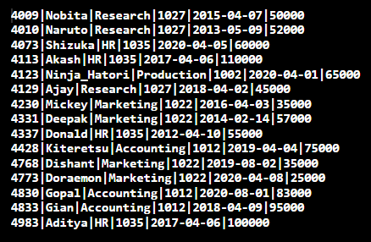

1. Display Manager Id of employees whose name starts with ‘A’.

**Query:**

**Q1)**

SELECT manager_id FROM EMPLOYEE WHERE emp_name LIKE 'A%'

**Q1) For Checking**

SELECT emp_name,manager_id FROM EMPLOYEE WHERE emp_name LIKE 'A%'

**Output:**

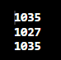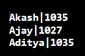

2. Display employees Id and employee name, department wise.

**Query:**

**Q2)**

SELECT emp_id,emp_name FROM EMPLOYEE ORDER BY department

**Q2) For Checking**

SELECT department,emp_id,emp_name FROM EMPLOYEE ORDER BY department

**Output:**

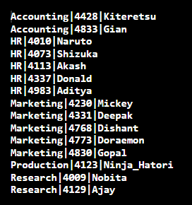

3. Display employee count department wise.

**Query:**

SELECT department,COUNT(*) FROM EMPLOYEE GROUP BY department

**Output:**

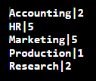

4. Display all columns of employees whose experience is more than 3 years.

**Query:**

SELECT * FROM EMPLOYEE WHERE (joining_date)<(DATE('now','-3 year'))

**Output:**

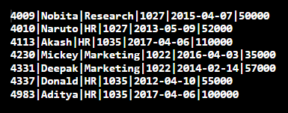

5. Display departments with more than 4 employees.

**Query:**

**Q5)**

SELECT department FROM EMPLOYEE GROUP BY department HAVING COUNT(*)>4

**Q5) For Checking**

SELECT department,COUNT(*) FROM EMPLOYEE GROUP BY department HAVING COUNT(*)>4

**Output:**



6. Display employees Id and employee name whose salary is greater than 50000, Department wise.

**Query:**

**Q6)**

SELECT emp_id, emp_name FROM EMPLOYEE GROUP BY department HAVING salary>50000

**Q6) For Checking**

SELECT emp_id, emp_name, salary FROM EMPLOYEE

GROUP BY department HAVING salary>50000

**Output:**

 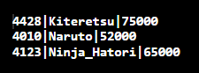

7. Display department name and average salary of employees in department wise.

**Query:**

SELECT department,AVG(salary) FROM EMPLOYEE GROUP BY department

**Output:**

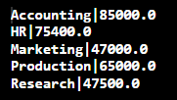

8. Display Employee Id and Name of employee with highest salary.

**Query:**

SELECT emp_id, emp_name, MAX(salary) FROM EMPLOYEE

**Output:**



9. Display employees Id and employee name with least salary

**Query:**

SELECT emp_id, emp_name, MIN(salary) FROM EMPLOYEE

**Output:**



10. Display employees Id and employee name with second highest salary.

**Query:**

SELECT emp_id, emp_name, MAX(salary) FROM EMPLOYEE

WHERE salary < (SELECT MAX(salary) FROM EMPLOYEE)

**Output:**



**Use Student table from Assignment 3**

1. Display semester of students whose name has the letter ‘a’.

2. Display count of students semester wise.

3. Display students' names from every department whose roll number is 1.

4. Display student name and semester of students who are not staying in the hostel.

5. Display student count in each semester whose birth month is august.

6. Display roll number and name of the student who was the first one to get admission in

the college.

7. Display the average count of students. ( In any semester)

8. For every month (Jan-Dec) display the count of students who are having birthdays in that

month.

9. Display count of students who have taken admission in the last six months.

10. Display semester with least number of students.

**Submitted By:**

**BHAGYA VINOD RANA**

**U19CS012**